Server Ip: 172.233.222.140

S1: 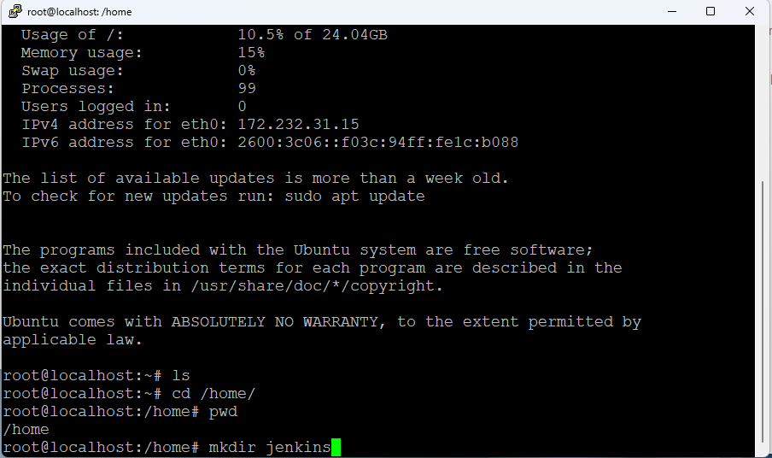

S2:

S4 & S5:

S7:

S8 & S9:

S10:

